Accessing Online Training

Click on the Support icon (?)

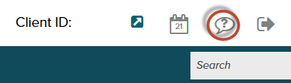

NOTE: It takes a little time for the online training site to load. During the load, the page will be blank.

On the right side of the page, you will have Learning Resources

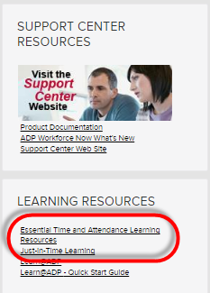

Click on Essential Time & Attendance Learning Resources link.

There are 3 categories of Learning Resources—Employee, Supervisor, and Practitioner and under each category there are links to the specific topics listed. You will find the link below.

**Time and attendance recorded Webcasts for managers:**

<https://reg.abcsignup.com/view/view_month.aspx?as=4&wp=372&aid=ADP>

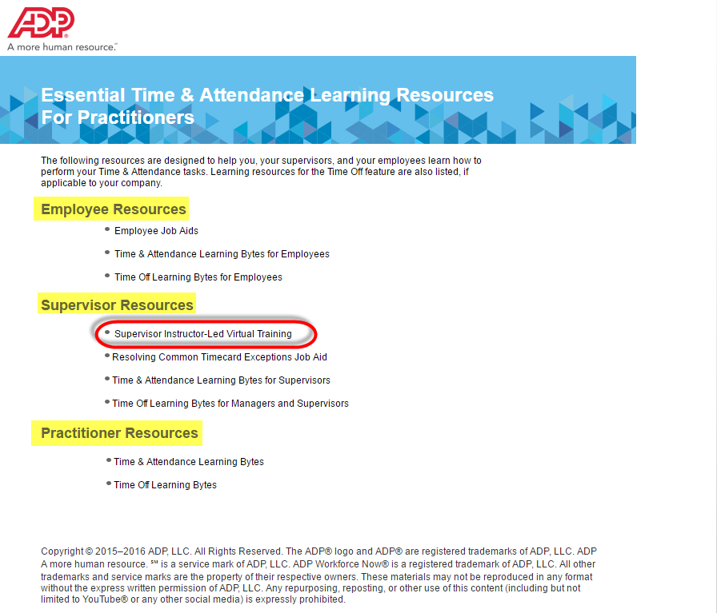

On-Demand Recorded Webcasts provide pre-recorded topics for Supervisors.

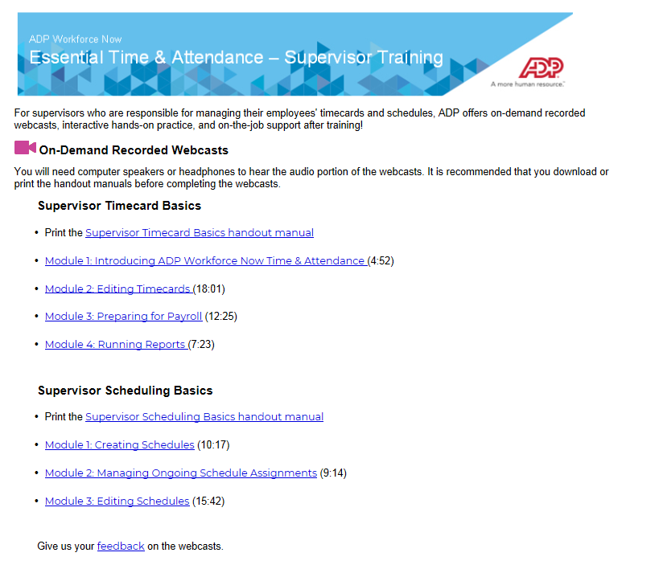

**Learning Bytes** provide additional pre-recorded tutorials for various Supervisor tasks. Once you click on Time & Attendance Learning Bytes for Supervisors, it will list the recordings available.

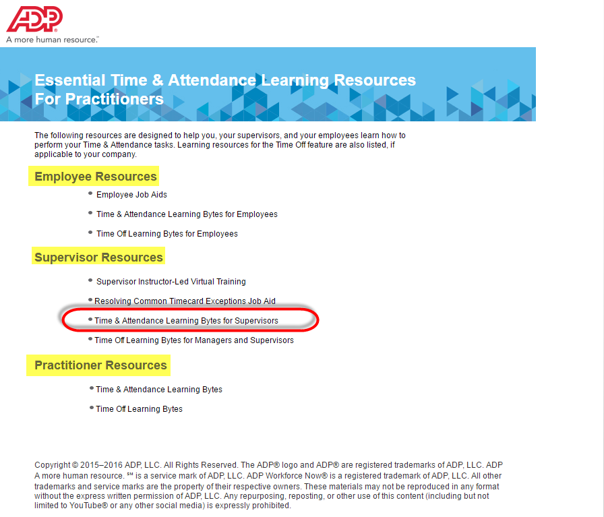

A sample list of topics is shown below. Managers would click on the topic and see an audio / visual guided tour of the topic. These can be accessed via this link as well: <https://support.adp.com/basic/cr/matraining/sims/wfn/80908/80908coursemenu.htm>

